2019+ Ford Ranger Trailer LED issue

I have seen a few folks with the problem of a Trailer with LED lights or a Trailer hitch cover with LED lights causing errors on the dash. This will work if you have the 8 pin connector or as described here the 4 pin connector.
Tools needed:
- Drill
- Step drill bit
- Resistors
- 1 Blue ring or spade connector
- Crimp tool or pliers

- Get these on Amazon https://www.amazon.com/dp/B0CSN7QW3X?ref=ppx_yo2ov_dt_b_fed_asin_title&th=1

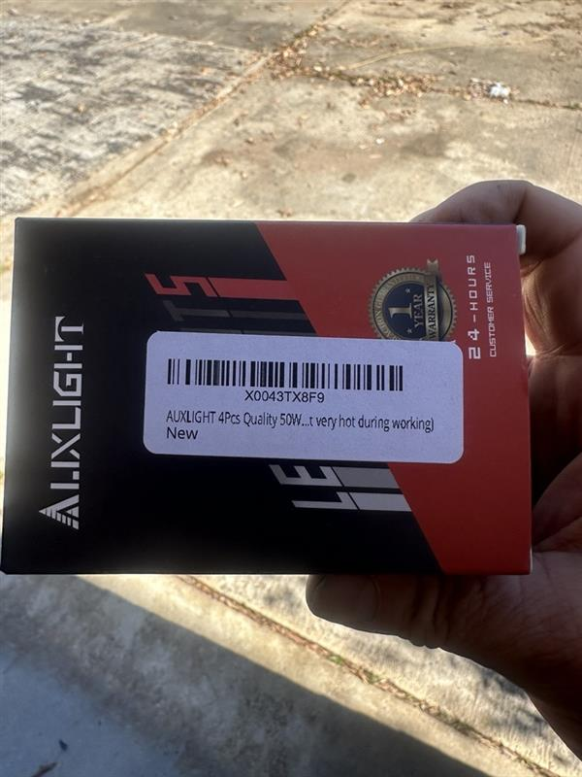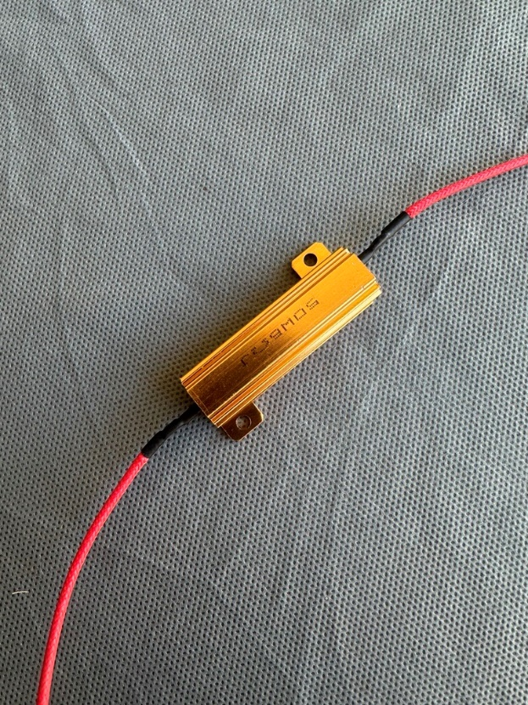
They come with the wire splices included
- Twist one wire from each of the resistors and crimp them together with a blue spade or ring connector.
- Using a step drill bit, drill 3, 1/8-inch holes (Second step on the bit, may need to enlarge the holes on the resistors as well) in the bumper frame next to the hitch cable connector on the truck.
- Using 3 1/8-inch (5-20) screws, mount the resistors to 2 holes the bumper frame screws and the crimped wires to the 3rd hole. (The heads on my screws were big but I was able to snug the resistors down)
- On the back of the truck connector, carefully cut back the protective tape and sheath a little to expose the wires. Locate the yellow and green wires going into the back of truck connector. (It may be easier to pull the 4-pin connector out of the mount)
- Using the included red splices splice the other end of one of the resistors to the yellow wire and one resistor to the green wire.

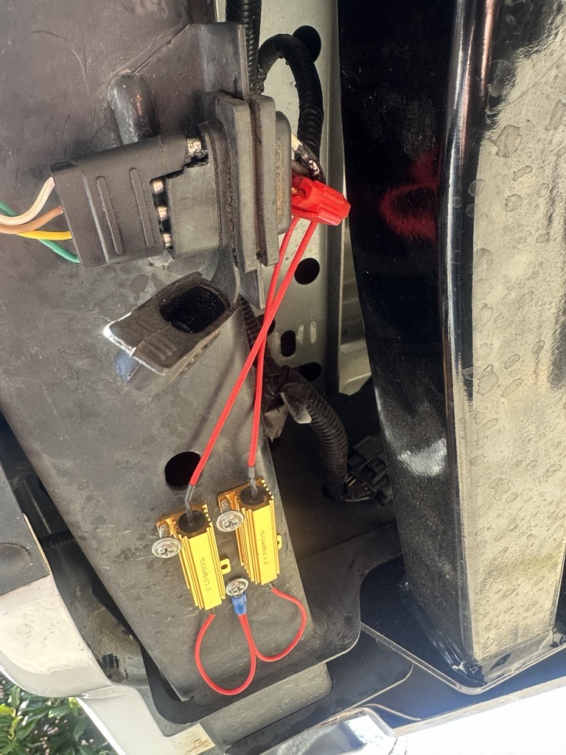

- Hook up the LED trailer or LED hitch cover and no more errors except for the trailer connected warning.

