Ford’s Spark Plug Inspection Guide

NOTE: Dropped spark plugs should always be discarded.

Unfired:
1. An unfired spark plug should appear very clean with a pure nickel finish to the threads and ground strap. The center electrode ceramic insulator surface is often a matte or dull finish and pure white in color. The external primary insulator is often a polished white ceramic with appropriate stamping labels. Some spark plugs have a smooth barrel while others have a ribbed barrel insulator. Ford spark plugs almost universally use a ribbed barrel with glazed blue rib peaks. The Anti-Fouling silicone oil treatment used on all Ford spark plugs may be tinted pink. Some suppliers use this to designate the silicone oil has been applied.
No corrective action necessary.
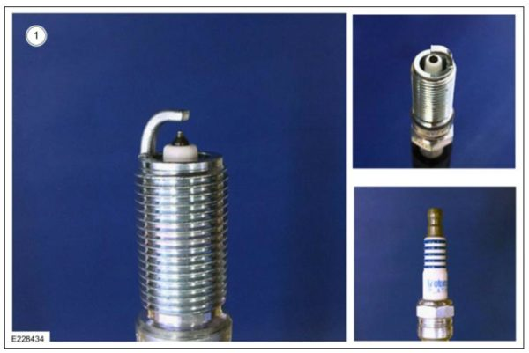

Normal Burning:
2. A normal burning spark plug will often present with a white or slightly off-white (brown or light gray) color center electrode and clean or mildly discolored ground strap.
No corrective action necessary.
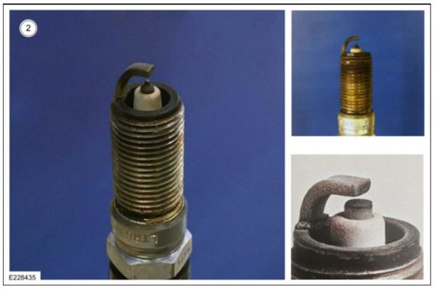

Carbon Fouling:
3. Carbon fouling can cause engine misfire. As carbon deposits, created during incomplete combustion, adhere to center electrode insulator surfaces, insulator dielectric and isolation or shunt resistance are compromised. In the case that sufficient carbon deposits are present on the center electrode and insulator surface the primary conduction path can change from spark creation to shorting through carbon deposits. This is also known as spark leakage. Upon shorting through carbon deposits, available voltage delivered to the center electrode tip is reduced until no spark is delivered to the mixture and a misfire occurs. Proper Heat Range selection is necessary to avoid pre-ignition and carbon fouling. Even with the proper Heat Range, avoid excessive cold starts and/or excessive idling at cold engine temperatures without a warm-up drive cycle. For proper self-cleaning, be sure to warm the spark plug using a medium-load drive cycle. A normal operating temperature for a spark plug may be 450-850°C (842-1562°F), at which point carbon deposits will burn off during spark plug self-cleaning.
A drive cycle of enough distance and rpm can clear the spark plugs of carbon fouling (ex: 4 mile drive at 3000 rpm).
Should this fail, install new spark plugs.
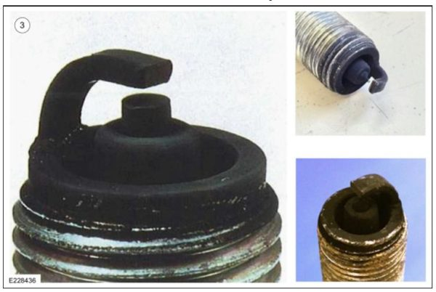

Lead Fouling and Erosion:
4. Lead fouling can occur in engines that use leaded gasoline. In modern engine applications, this failure mode is rare, as TEL (Tetraethyllead) was removed from consumer use at fuel filling stations long ago. Lead fouling can occur on engines used in high compression racing engines and, in some limited cases, aviation applications. Spark plugs that have been used in the presence of lead are characteristically identified by a yellow/brown tinted center electrode insulator and can cause engine misfire at high engine speed and high load. Additionally, ground strap electrodes will often be worn in engines exposed to leaded fuel for extended periods of time. This failure mode is caused by the tendency for lead compounds to react chemically with nickel electrode materials at high temperatures. These chemical reactions often cause increased brittleness and reduced material strength in the ground electrode.
Alert the customer to avoid using leaded fuel and/or octane enhancer.
Inspect the CMS (catalyst monitor sensor) and the HO2S for evidence of lead damage.
Install new spark plugs.
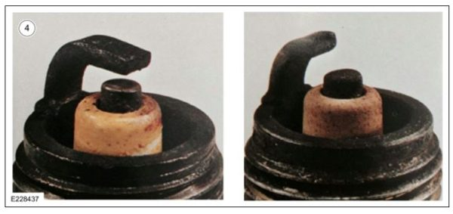

Coolant / Oil Wet Fouling:
5. Wet fouling is most often caused by excess fuel, oil, or coolant within the combustion chamber during operation. Spark plugs that are wet fouled often cause poor starting and misfiring. Often, a wet fouled spark plug is indicative of additional mechanical issues within the engine system such as a compromised head gasket, oil leakage past the control ring, or valve train leakage. In certain cases, other causes could be low compression, vacuum leaks, overly retarded timing, or improper spark plug heat range. The primary cause of misfire is the low resistance path created by oil, fuel, or coolant deposits. Wet materials provide a lower resistance path for spark leakage from the high voltage center electrode to ground. When driving with a coolant leak for an extended time, the plug may be cleaned.
Check for wet, black deposits on the insulator shell bore electrodes, caused by excessive oil entering the combustion chamber through worn rings and pistons, excessive valve-to-guide clearance or worn or loose bearings.
Correct the coolant or oil leak concern.
Install new spark plugs.
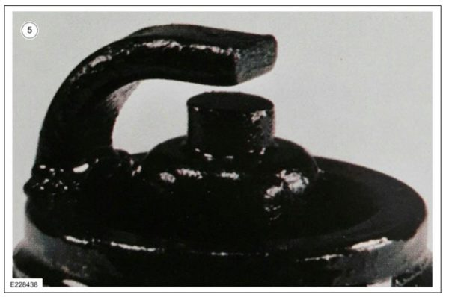

Deposit Buildup:
6. The presence of deposits on the spark plug can be indicative of oil leakage or poor fuel quality. Often, these ashy coatings cause misfires as a low resistance path from center electrode to ground is created.
Correct the oil leak, if necessary.
Inform the customer of possible poor quality fuel.
Install new spark plugs.
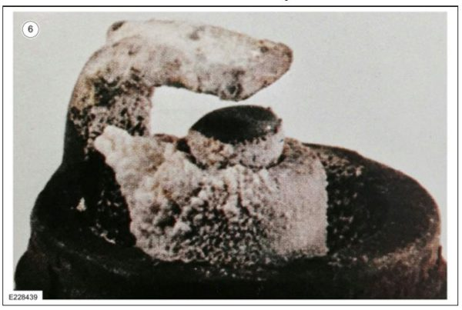

Abnormal Erosion/Corrosion/Oxidation:
7. Often, eroded, corroded, or oxidized spark plug conditions occur as a result of leaded gasoline, which reacts with electrode materials (see Lead Fouling). These symptoms appear as pitted, cracked, or eroded electrodes and on occasion will display with a green cast if copper oxidation is heavy. These conditions result in increased, improper spark plug gap and yield poor performance. More recently, the use of Ethanol fuel blends of E85 (85% Ethanol) can create this Oxidation condition. The Heat Range selection for E85 applications typically is 1 range colder due to added spark advance used to make up for the loss of performance. The hotter tip temperatures combined with the rapid thermal cycle on the electrode surface initiates surface cracks and eventual oxidation based corrosion.
Verify E85 isn’t being used in a vehicle not designated for E85 usage (Flex Fuel Vehicle).
Install new spark plugs.
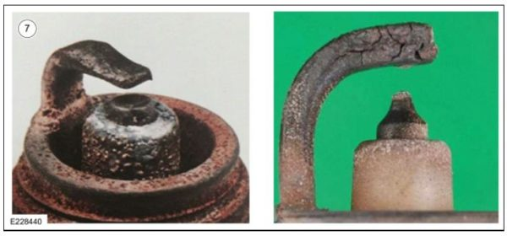

Ground Electrode Breakage:
8. Ground electrode breakage can be caused by pre-ignition or any other excess shock load. Ground electrode breaks may be caused by incorrect ignition timing, wrong type of fuel, or unauthorized installation of a reduced thermal conductivity Heli-Coil insert in place of the spark plug threads.
Confirm the proper fuel and ignition timing.
Confirm the proper heat range of spark plugs.
Confirm that the cylinder head threads have not been repaired with a Heli-Coil thread repair kit.
Install new spark plugs.
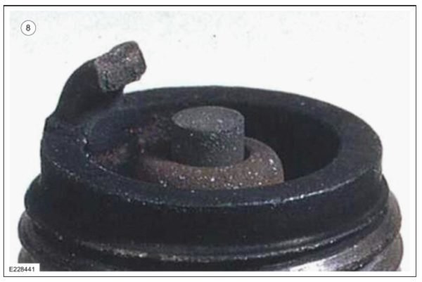

MMT Fouling (Hot Plug Fouling):
9. MMT (Methylcyclopentadienyl Manganese Tricarbonyl) is often used as an octane booster in combination with poor quality fuels to bring octane levels within acceptable limits. If excess Mn (Manganese) levels are present in the fuel during combustion, Mn deposits can foul the combustion chamber, catalytic converters, and spark plugs. Mn in higher concentrations can lead to pre-ignition and engine misfire. Mn deposit become conductive as the surface exceeds ~550°C (1022°F). For this reason the failure mode is referred to as Hot Plug Fouling. As MMT is high in manganese, a reddish coating will be present on the spark plug insulator and ground electrodes. The reddish coating is often covered up by carbon fouling if the spark plug is to the point of misfire.
Advise the customer to avoid use of leaded fuel and/or octane enhancer.
Inspect the CMS and the HO2S for evidence of MMT damage.
Install new spark plugs.
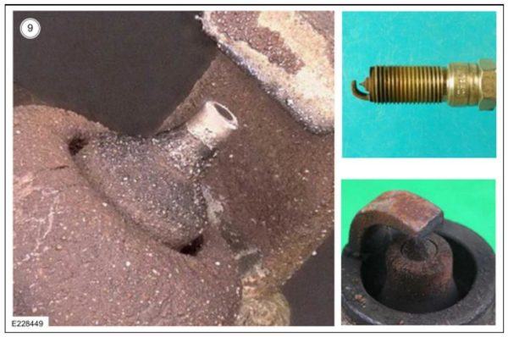

Ferrocene Fouling (Hot Plug Fouling):
10. Ferrocene (metallocene) is an organometallic compound often used in place of MMT as an octane booster and presents itself with a bright orange surface color. If excess ferrocene levels are present in the fuel during combustion, ferrocene deposits can foul the combustion chamber, catalytic converters, and spark plugs. Deposit become conductive as the surface exceeds ~450°C (842°F). For this reason the failure mode is referred to as Hot Plug Fouling. Ferrocene in higher concentrations can lead to pre-ignition and engine misfire.
Advise the customer that they may be using leaded fuel and/or octane enhancer. Ask them to stop.
Inspect the CMS and the HO2S for evidence of ferrocene damage.
Install new spark plugs.
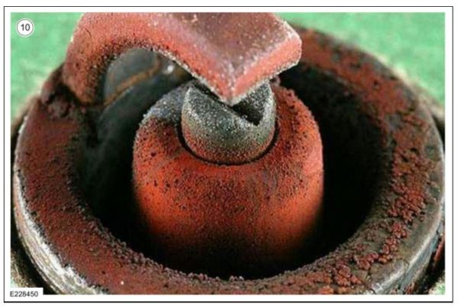

Overheating and Melted Electrodes:
11. Symptoms of overheating include white or light gray spots and a bluish-burnt appearance of the electrodes. This is caused by engine overheating, wrong type of fuel, loose spark plugs, spark plugs with an incorrect heat range, low fuel pump pressure, or incorrect ignition timing. Fused deposits present with melted or spotty deposits resembling bubbles or blisters and are indicative of sudden acceleration.
Confirm proper fuel and ignition timing.
Confirm proper heat range of spark plugs.
Check the coolant system for leaks and blockages, and check water pump for malfunction.
Repair coolant system and refill coolant, as necessary.
Install new spark plugs.
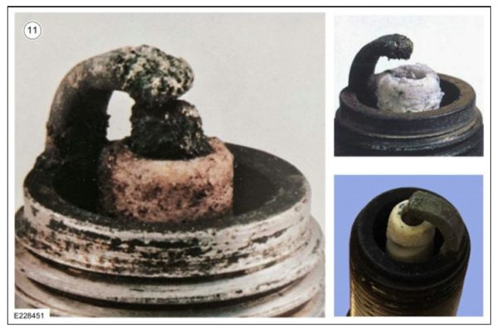

Insulator Damage and Breakage:
12. NOTE: Upper right hand insert shows dielectric puncture typically due to excessively worn gaps.
Center electrode insulator breakage is often caused by a sudden thermal shock due to sudden heating or cooling. It can also be caused by mechanical load from an external source (droppage) or can even be caused by pre-ignition events where side loading from combustion pressure shock waves is strong enough to fracture the ceramic insulator material. Hotter heat range spark plugs have a longer insulator to reduce the spark plug fouling risk, but are also weaker to fracture during low speed pre-ignition events due to increase bending moment arm. Oil or Sulfur Oxide migration between the center electrode and the inner diameter of the insulator can cause internal outward force sufficient to create a “u” shaped fracture. See Sodium/Oil Migration section for further detail of this failure mode.
Install new spark plugs.
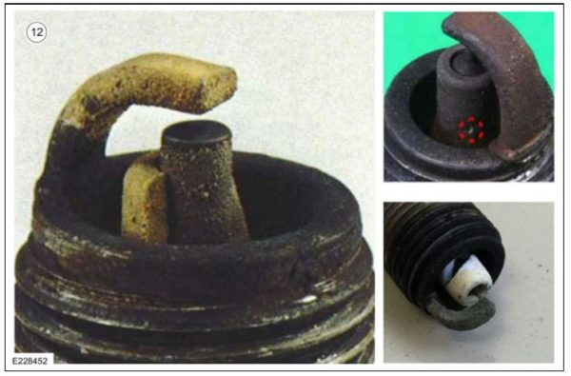

Sodium/Oil Migration:
13. In the case of oil migration, misted oil is absorbed into the combustion chamber during charge intake. For cylinder deactivation, valves remain closed and oil within the chamber does not combust. Misted oil adheres to the spark plug surfaces and oil penetrates into the clearance volume between the insulator and center electrode via capillary action. During cylinder reactivation, oil near the surface is burned off, while soot (carbon deposits) is generated within clearance volumes due to incomplete combustion. During spark plug reheating, the center electrode thermally expands at a much greater rate than the insulator, causing compressive stresses within the center electrode and tensile stresses on the electrode insulator exterior. These stresses can fracture the ceramic insulator if sufficiently high. In sodium migration, sodium sulfate is created during combustion and deposits form in the clearance volume between center electrode and insulator. Currently, the source of sodium sulfate is not known, although it is believed to originate from E100 fuel. Present theory suggests that failure is caused by electrode/insulator locking, where electrode and insulator are mechanically joined by the sodium sulfate. During cool down, the electrode contracts and increases in diameter, which pushes (via sodium sulfate) against the insulator and causes failure in the same manner as seen in oil migration.
Install new spark plugs.
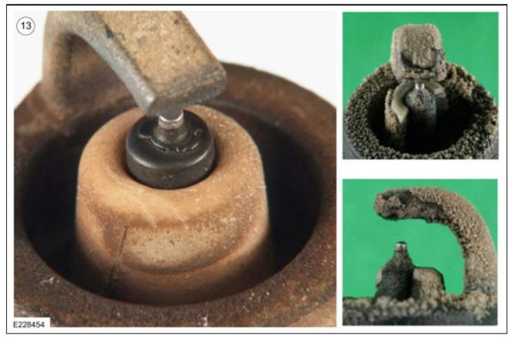

Bridged Gap:
14. A bridged spark plug gap is often caused by fuel droplets present in the ion gap when spark is commanded. The spark event conducts through the fuel droplet leaving behind a carbon fiber. Other contributors include deposit build up on the electrode surface which is indicative of carbon or oil fouling. Often, this condition can present itself after many low and medium load cycles. Carbon deposits within the combustion chamber can break free during sudden applications of high load, lodge within the spark plug gap, and provide a dead short to ground.
Install new spark plugs.
A drive of between 4-10 miles targeting 3000 rpm will bring the plug to self-cleaning temperature.
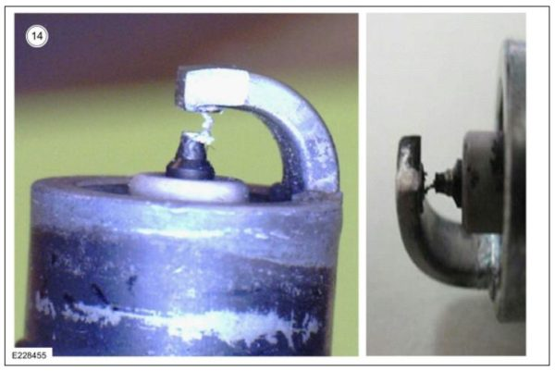

Wrench Breaking Cracks:
15. Wrench breaking cracks are typically caused either by side load or torque applied from a socket of incorrect size. Impact loading can and will often crack the insulator shell as the porcelain is very brittle with very little strength under tension. Force direction is often easily determined as the ceramic often cracks vertically (although typically asymmetric about the centerline).
Avoid using anything but a spark plug socket and hand tools to better prevent these cracks.
Install new spark plugs.
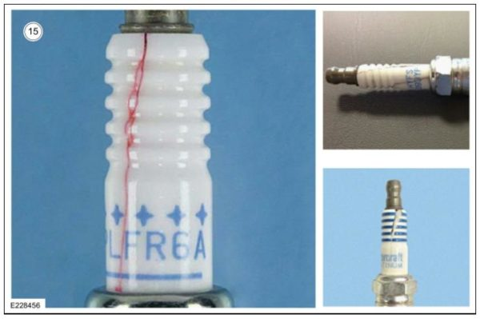

Tracking/Flashover:
16. Tracking marks are markings left behind when a high voltage discharge occurs from electrode to ground through something other than the air gap at the spark plug end. Most often, these discharges occur along the primarily insulator (under/near the boot) and on the center electrode insulator. These discharges typically scorch the porcelain ceramic and leave a brown burned visual indicator. In the primary photo, a large brown scorch mark is apparent. In the upper secondary photo, track marks are present along each rib. In the lower secondary photo, which shows a case of typical carbon fouling, track marks are present along the primary center electrode insulator as the spark current tracked along the insulator until it jumped sideways to the metal shell.
Install new spark plugs.
Install new ignition coil boot (if tracking is above the hex).
If tracking is present above the hex, both of the above parts must be changed at the same time because the track is present on both components. If only one is changed, the problem will persist and a return visit is very likely.
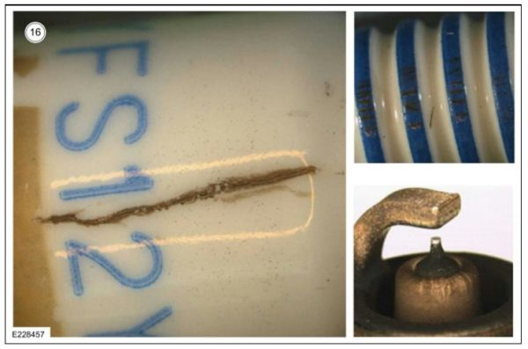

Corona Stain:
17. A brown stain near where the insulator joins the metal shell of the spark plug is often called a corona stain and is produced when oil particles present in the air near the engine adhere to the insulator surface. Corona discharge occurs when high voltage applied to the conductor on top of the spark plug causes an insulation breakdown of the air gap between the insulator and metal shell. Corona stain does not affect spark plug performance. In the upper right photograph, tracking marks are present indicating evidence of flash over on ribs, but stop once the corona stain is reached. This suggests the corona stain is not conductive, even in the presence of high kilovolts during normal operation. The lower right photo demonstrates corona staining on the inside of a boot.
No corrective action is necessary if only a corona stain is present.
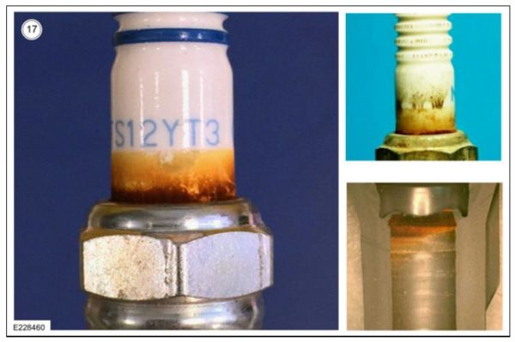

Center Electrode Bending/Breaking from Pre-Ignition Events (Rattler):
18. Under extreme pre-ignition events, a shock wave traveling across the combustion chamber can bend the center electrode and break the center electrode porcelain insulator. Under these extreme circumstances, a “rattler” can be formed where the center electrode insulation breaks free of the spark plug and rattles under vibration. In the photos, a bent center electrode is highlighted in the main photo while the upper secondary photo shows the fracture surface of a broken insulator and the lower secondary photo shows a spark plug with a detached center electrode insulator.
Install new spark plugs.
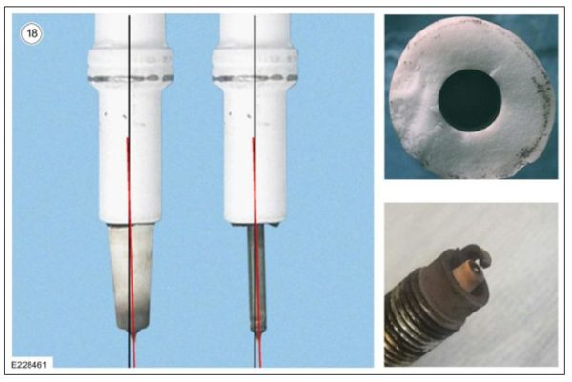

Corrosion (Water Damage):
19. Corrosion found on the wrench/threaded area can be a sign that the spark plug has experienced moisture and heat. Often this condition occurs when water has penetrated spark plug tube seals and entered the spark plug tube. Many times, this corroded spark plug also displays symptoms of misfire (as water provides a low resistance path from high voltage coil to ground) and the combustion chamber interface (center electrode and ground strap) will often be heavily carbon fouled.
Check for the source of water intrusion and correct as necessary.
Install new spark plugs.
Install new ignition coil and boot assembly.
Advise the customer to avoid direct water spray on the coil boots.


